I created a workbook (attached) that uses the device code OAuth flow for user login to allow the user to open their web browser to complete the login process. When you click the Login button it will show a URL and a 1-time code that you can type into your web browser. Then, you can log in using your normal user credentials. Once logged in, it will get the title of the configured SharePoint site.



To setup the Azure AD App do the following (should show some animated gifs):

1. Create a new app

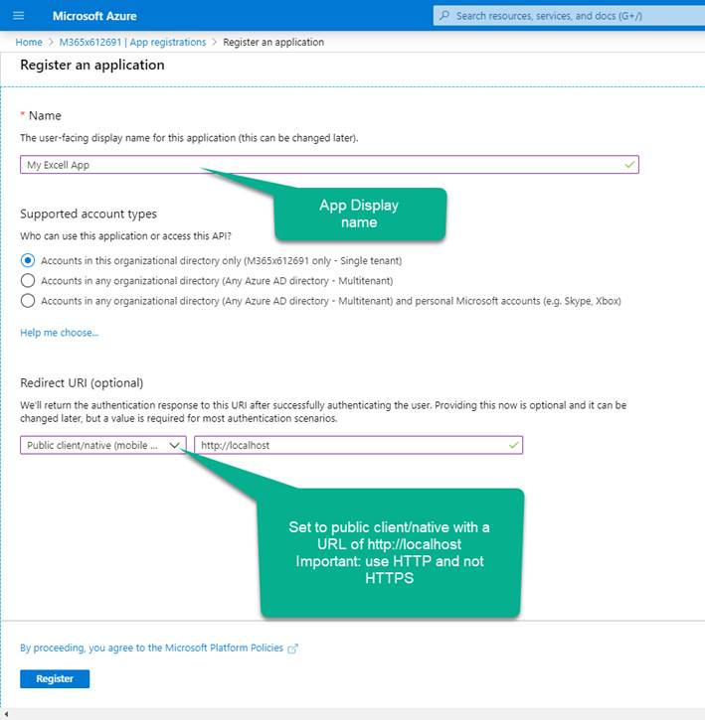

1. Set the client type to public client

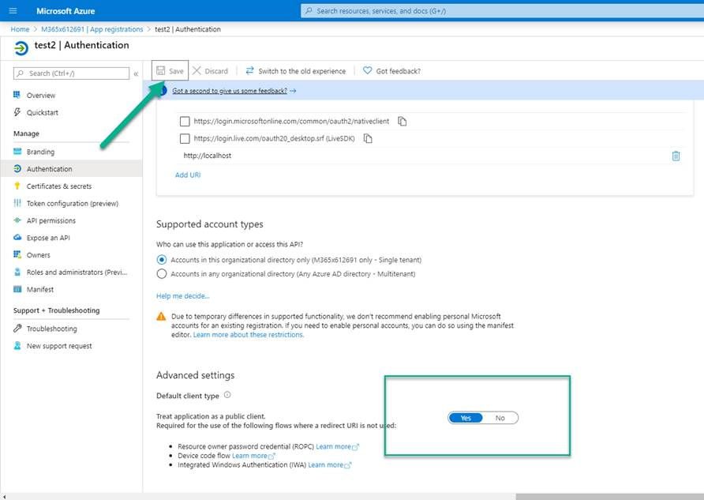

1. Graph desired permissions. The animation below grants users the ability to access any SharePoint site in which they have already been granted permissions.



1. Go to the overview blade to get the app id and tenant id

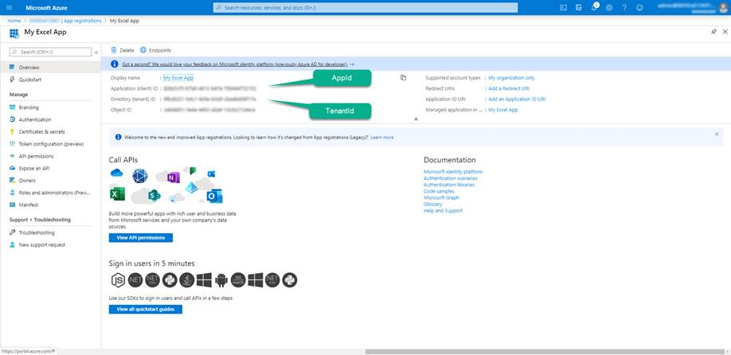

Open the attached Excel file and open the Visual Basic editor

1. Right-click LoginForm in code view and change the constants at the top of the file

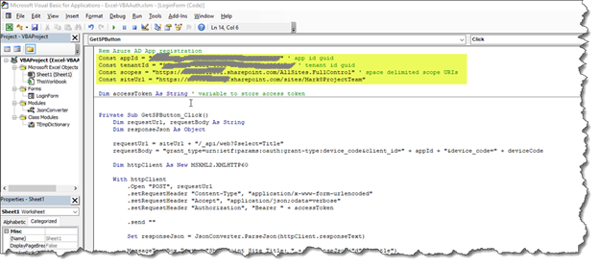

appId = Application (client) ID from the Overview blade of your app registration

tenantId = Directory (tenant) ID from the Overview blade of your app registration

scopes = space dlimited scope URIs that correspond to the permissions granted in the API permission of your app registration. For SharePoint it is in the form https://tenant.sharepoint.com/permission

siteUrl = A SharePoint site in which to query for the title. The user logging in will need permissions to this site.